EADS NA Defense

Software Design Document

Digital Scope Functionality

WCEM Driver – WcemDSO.dll

SDD-WcemDSO
Version 0.00
12/02/05

This document and the information contained herein are proprietary to EADS NA Defense and may not be disclosed in whole or in part to any parties without the expressed written consent of EADS NA Defense.

PAWS is a registered trademark of the TYX Corporation.

© EADS NA Defense
1222 Lucas Ave. Suite 200
St. Louis MO 63103
phone (314) 727 1337
fax (314) 727 6750

Software Design Document

Version 0.00

History of changes
0: Initial Release

Change Table

Change | Date | Paragraph
 | 12/2/05 | 5.2 Added TIME INTERVAL noun and its modifiers.
 | 01/31/06 | 5.2 Changed Bandwidth range starting at 450 hz and not 0 hz

1 Scope 5
1.1 Identification 5
1.2 System Overview 5
1.3 Document Overview 5
2 Reference Documents 5
3 System-Wide Design Overview 5
3.1 Assumptions and Dependencies 5
3.2 General Constraints 5
3.3 Goals and Guidelines 6
3.4 Safety and Security Considerations 6
3.5 Development Methods 6
4 System Architectural Design 6
4.1 System Components 7
4.2 Interface design 8
5 Detailed Design 9
5.1 Classification 9
5.2 ATLAS Modifier Definition 9
5.3 Port Names 13
5.4 Processing 14
6 Requirements traceability. 14
7 Notes 14
7.1 Measure Frequency AC Signal 14
7.2 Measure 200 Samples of a Waveform 14
7.3 Save a Waveform 14
7.4 Differentiate a Waveform 14
8 Appendix A – Mathematical Equations 15

Scope

Identification
The software configuration component WcemDSO.dll provides the software routines necessary to control the Digital Scope.

System Overview
The PAWS system provides several methods of interfacing the compiled ATLAS object code with the test system instruments. The method used by this module is the Windows CIIL Emulation Module (WCEM). This mode of instrument control, the PAWS WRTS calls the WcemDSO.dll via ATLAS single action verb related functions. The WcemDSO.dll queries the WRTS for modifier values and other parameters and sends the necessary commands to the instrument.

Document Overview
The document defines the detailed software design for the PAWS WCEM driver for the DSO. This document specifies the value ranges of all the ATLAS modifiers and modifier value ranges and how they are used to control the Digital Scope.

Reference Documents
- ARC PAWS WCEM Software Development Style Guide (ARCSTL-DSG-000)
- Software Requirements Specification for Third Echelon Test Set DEFCOT&S-3536-SRS-001
- PERFORMANCE SPECIFICATION FOR THE THIRD ECHELON TEST SET (TETS) MARCORSYSCOM-PD-02-001 12/1/2003
- Computer Programming Manual (CPM) for the Third Echelon Test System (TETS) REV. E P/N 93006A0026
- IEEE std. 716-1989 C/ATLAS Test Language
- General Notes for ATLAS Implementation Doc # 7992052 Rev.01 Aug 10 2005

System-Wide Design Overview
The PAWS development system provides the ability to code a test program in an extended / subset of the IEEE std. 716-1989 C/ATLAS Test Language. The PAWS development system provides the ability to modify the ATLAS subset with special nouns and modifiers (primarily analog) to meet special requirements.

Assumptions and Dependencies
The following assumptions and dependencies are made:
- The TETS ATLAS subset will contain the common ATLAS extensions found in most extended subsets of ATLAS (e.g. TRIG-SOURCE, TRIG-SLOPE, etc.)
- The TETS ATLAS subset will contain all required legacy ATLAS extensions that are not replaceable with the standard or common ATLAS extensions.
- The full instrument range will be implemented when they exceed the ranges in the system requirements specification.
- The full functionality of the instrument will be implemented to the extent possible where the ATLAS mapping can be defined. (Detailed below).

General Constraints
The sections below will detail which of the ATLAS modifiers are used and how they are used to control the DSO.

Goals and Guidelines
- To the extent possible, map the ATLAS modifiers to instrument controls in a common sense manner.
- Implement the full range and functionality as can be supported by the extended subset of ATLAS.

Safety and Security Considerations
No safety or security considerations for this instrument.

Development Methods
As described in the “ARC PAWS WCEM Software Development Style Guide”.

System Architectural Design
The PAWS WCEM driver is invoked on TPS load, TPS Unload, WRTS “Reset” / ATLAS “REMOVE, ALL”, and the derived “Single Action” ATLAS actions. The following diagram shows the major functions called from the WRTS through tables created by the WCEM Wizard in Wrapper.cpp. (See the “ARC PAWS WCEM Software Development Style Guide” for details). The essence of the WCEM driver is defined as a class CDSO. When multiple instruments (DSOs) are available in the station, instances of the CDSO class will be instantiated. Therefore, the member variables and methods need only control a single instrument.
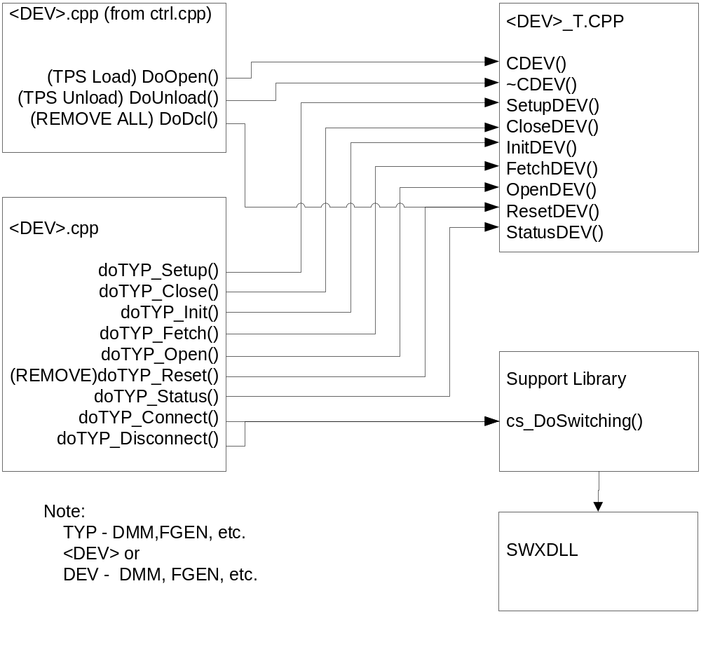
Figure 4.0 WCEM Function Relationships

System Components
The WCEM driver will consist of:
- A Microsoft Visual C++ project to build the WCEM
  - WCEM Wizard generated interface files
    - Wrapper.cpp
    - error.cpp
    - key.h
  - Configuration Information
    - DSO.rc
    - resource.h
  - Updated Template File
    - DSO.cpp
  - The programmer generated driver file DSO_T.cpp

- A PAWS Developer’s Studio project file for the benchmark DSO.PAW
  - An ATLAS program or programs to test the driver (Benchmark)
  - A Device Database static Description

Interface design

Function | Purpose
CDSO(bool sim, int dbglvl, int addr) | This function is used to initialize the instrument, obtain a handle from VISA or other controller software, and establish if the device is in simulation mode and / or debug.
~CDSO(void) | This function shuts down the instrument and releases the device handle.
SetupDSO(int fnc) | This function is the entry point for the setup action. The argument is the FNC number from the DeviceDB Static Description.
StatusDSO(void) | This function queries the instrument for status and reports any errors to the RTS via the error handling mechanisms
FetchDSO(int fnc) | This function is responsible for retrieving measured values from the instrument and returns them to the RTS via the fetch API in WCEM or other support libraries
InitiateDSO(int fnc) | This function controls the ATLAS INITIATE actions and is responsible for enabling or triggering a signal
ResetDSO(int fnc) | This function is responsible for resetting the instrument. The argument 0 will be reserved for a RESETALL action and shall reset the instrument regardless of the current state of the device. Arguments > 0 may use a state variable to determine if the device is currently reset.
CloseDSO(int fnc) | This function is responsible for the ATLAS CLOSE verb and shall close any internal relays within the instrument and will enable the output or input to the device.
OpenDSO(int fnc) | This function is responsible for the ATLAS OPEN verb and will disable the output or input of the instrument.

Detailed Design

Classification
This module is unclassified.

ATLAS Modifier Definition

The following table specifies the Nouns / Measured Characteristics / Modifiers used to control the DSO:

Modifier | Dim | Value Range | Default | XML | Misc
(FREQ) AC SIGNAL, (PERIOD) AC SIGNAL, (VOLTAGE-PP) AC SIGNAL, (AV-VOLTAGE) AC SIGNAL, (VOLTAGE-P) AC SIGNAL, (VOLTAGE) AC SIGNAL
FREQ | Hz | .02 Hz to 200 MHz
PERIOD | Sec | 5 nSec to 50 Sec
VOLTAGE-PP | V | 0 to 40 V
AV-VOLTAGE | V | 0 to 40 V
DC-OFFSET | V | -250 V to 250 V | 0 V
FREQ-WINDOW | Hz | 450 Hz to 30 MHz
SAMPLE-COUNT |  | 1 to 2048;  (0 to 2048 for AV-VOLTAGE)
TRIG-LEVEL | V | - 310 V to 310 V
TRIG-SLOPE |  | POS, NEG
VOLTAGE-P | V | 0 V to 50 V
BANDWIDTH | Hz | 450 Hz to 30 MHz
(VOLTAGE) DC SIGNAL
VOLTAGE | V | -40 V to 40 V
SAMPLE-COUNT |  | 1 to 2048
TRIG-SLOPE |  | NEG;POS
TRIG-LEVEL | V | -310 V to 310 V
(PRF) PULSED DC, (PULSE-WIDTH) PULSED DC, (VOLTAGE-P-POS) PULSED DC, (VOLTAGE-P-NEG) PULSED DC, (VOLTAGE-PP) PULSED DC, (RISE-TIME) PULSED DC, (FALL-TIME) PULSED DC, (DUTY-CYCLE) PULSED DC, (OVERSHOOT) PULSED DC, (PRESHOOT) PULSED DC, (VOLTAGE-P) PULSED DC, (PERIOD) PULSED DC, (POS-PULSE-WIDTH) PULSED DC, (NEG-PULSE-WIDTH) PULSED DC
PERIOD | Sec | 5 nSec to 50 Sec
PRF | Hz | .02 Hz to 200 MHz
PULSE-WIDTH | Sec | 10 nSec to 50 Sec
NEG-PULSE-WIDTH | Sec | 10 nSec to 50 Sec
POS-PULSE-WIDTH | Sec | 10 nSec to 50 Sec
VOLTAGE-PP | V | 0 V to 40 V
VOLTAGE-P | V | 0 V to 50 V
VOLTAGE-P-POS | V | 0 V to 40 V
VOLTAGE-P-NEG | V | 0 V to 40 V
FALL-TIME | Sec | 12 nSec to 50 Sec
RISE-TIME | Sec | 12 nSec to 50 Sec
DUTY-CYCLE | Pc | 0 pc to 100 pc
OVERSHOOT | Pc | 0 pc to 100 pc
PRESHOOT | Pc | 0 pc to 100 pc
DC-OFFSET | V | -250 V to 250 V | 0 V
SAMPLE-COUNT |  | 1 to 2048
TRIG-LEVEL | V | -310 V to 310 V
TRIG-SLOPE |  | POS, NEG
(VOLTAGE-PP) RAMP SIGNAL, (FREQ) RAMP SIGNAL, (FALL-TIME) RAMP SIGNAL, (RISE-TIME) RAMP SIGNAL, (VOLTAGE-P) RAMP SIGNAL, (VOLTAGE-P-POS) RAMP SIGNAL, (VOLTAGE-P-NEG) RAMP SIGNAL, (PERIOD) RAMP SIGNAL
FREQ | Hz | .02 Hz to 200 MHz
VOLTAGE-PP | V | 0 V to 40 V
FALL-TIME | Sec | 12 nSec to 40 Sec
RISE-TIME | Sec | 12 nSec to 40 Sec
DC-OFFSET | V | -250 V to 250 V
VOLTAGE-P | V | 0 V to 50 V
VOLTAGE-P-POS | V | 0 V to 40 V
VOLTAGE-P-NEG | V | 0 V to 40 V
SAMPLE-COUNT |  | 1 to 2048
TRIG-LEVEL | V | -310 V to 310 V
TRIG-SLOPE |  | POS, NEG
BANDWIDTH | Hz | 450 Hz to 30 MHz
PERIOD | Sec | 5 nSec to 50 Sec
(FREQ) SQUARE WAVE, (FALL-TIME) SQUARE WAVE, (RISE-TIME) SQUARE WAVE, (VOLTAGE-PP) SQUARE WAVE, (DUTY-CYCLE) SQUARE WAVE, (VOLTAGE-P) SQUARE WAVE, (VOLTAGE-P-POS) SQUARE WAVE, (VOLTAGE-P-NEG) SQUARE WAVE, (PERIOD) SQUARE WAVE
FREQ | Hz | .02 Hz to 200 MHz |  |  | Used to calc Sample Rate = 1 / (FREQ * 10) when measuring FREQ, VOLTAGE-P, VOLTAGE-PP.
VOLTAGE-PP | V | 0 V to 40 V |  |  | Equivalent device function (V) (Note 2).
FALL-TIME | Sec | 12 nSec to 40 Sec |  |  | Used to calc Sample Rate = FALL-TIME / 4.0 when measuring FALL-TIME
RISE-TIME | Sec | 12 nSec to 40 Sec |  |  | Used to calc Sample Rate = RISE-TIME / 4.0 when measuring RISE-TIME
DUTY-CYCLE | Pc | 0 Pc to 100 Pc
PERIOD | Sec | 5 nSec to 50 Sec |  |  | 1/Freq
BANDWIDTH | Hz | 450 Hz to 30 MHz |  |  | Serves no purpose.
OVERSHOOT | Pc | 0 pc to 100 pc
PRESHOOT | Pc | 0 pc to 100 pc
DC-OFFSET | V | -250 V to 250 V | 0 V
PULSE-WIDTH | Sec | 10 nSec to 50 Sec
VOLTAGE-P | V | 0 V to 50 V
VOLTAGE-P-POS | V | 0 V to 40 V
VOLTAGE-P-NEG | V | 0 V to 40 V
SAMPLE-COUNT |  | 1 to 2048
TRIG-LEVEL | V | -310 V to 310 V
TRIG-SLOPE |  | POS, NEG
(FALL-TIME) TRIANGULAR WAVE SIGNAL, (FREQ) TRIANGULAR WAVE SIGNAL, (RISE-TIME) TRIANGULAR WAVE SIGNAL, (DUTY-CYCLE) TRIANGULAR WAVE SIGNAL, (VOLTAGE-PP) TRIANGULAR WAVE SIGNAL, (VOLTAGE-P) TRIANGULAR WAVE SIGNAL, (VOLTAGE-P-POS) TRIANGULAR WAVE SIGNAL, (VOLTAGE-P-NEG) TRIANGULAR WAVE SIGNAL, (PERIOD) TRIANGULAR WAVE SIGNAL
FREQ | Hz | .02 Hz to 200 MHz
VOLTAGE-PP | V | 0 V to 40 V
FALL-TIME | Sec | 12 nSec to 40 Sec
RISE-TIME | Sec | 12 nSec to 40 Sec
DC-OFFSET | V | -250 V to 250 V | 0 V
PULSE-WIDTH | Sec | 10 nSec to 50 Sec
VOLTAGE-P | V | 0 V to 50 V
VOLTAGE-P-POS | V | 0 V to 40 V
VOLTAGE-P-NEG | V | 0 V to 40 V
SAMPLE-COUNT |  | 1 to 2048
TRIG-LEVEL | V | -310 V to 310 V
TRIG-SLOPE |  | POS, NEG
PERIOD | Sec | 5 nSec to 50 Sec
DUTY-CYCLE | Pc | 0 Pc to 100 Pc
BANDWIDTH | Hz | 450 Hz to 30 MHz
(SAVE-WAVE) WAVEFORM, (LOAD-WAVE) WAVEFORM, (COMPARE-WAVE) WAVEFORM, (MATH) WAVEFORM, (SAMPLE) WAVEFORM
SAVE-WAVE |  | 0 to 8000
SAVE-FROM |  | chan1, chan2, wmem1, wmem2, wmem3, wmem4, func1, func2
SAVE-TO |  | wmem1, wmem2, wmem3, wmem4
LOAD-WAVE |  | 0 to 8000
LOAD-FROM |  | chan1, chan2, wmem1, wmem2, wmem3, wmem4, func1, func2
COMPARE-WAVE |  | 0 to 8000
COMPARE-CH |  | chan1, chan2
COMPARE-TO |  | wmem1, wmem2, wmem3, wmem4
ALLOWANCE |  | 0 to 8
MATH |  | 0 to 8000
ADD-FROM |  | chan1, chan2, wmem1, wmem2, wmem3, wmem4
ADD-TO |  | chan1, chan2, wmem1, wmem2, wmem3, wmem4
SUBTRACT-FROM |  | chan1, chan2, wmem1, wmem2, wmem3, wmem4
SUBTRACT-TO |  | chan1, chan2, wmem1, wmem2, wmem3, wmem4
MULTP-FROM |  | chan1, chan2, wmem1, wmem2, wmem3, wmem4
MULTP-TO |  | chan1, chan2, wmem1, wmem2, wmem3, wmem4
DIFFERENTIATE |  | chan1, chan2, wmem1, wmem2, wmem3, wmem4
INTEGRATE |  | chan1, chan2, wmem1, wmem2, wmem3, wmem4
DESTINATION |  | func1, func2
SAMPLE |  | 0 to 8000
DC-OFFSET | V | -250 V to 250 V
VOLTAGE-PP | V | 0 V to 40 V
SAMPLE-TIME | Sec | 160 nSec to 800 Sec
RESP |  | 0 to 8000
COMMON MODIFIERS
MAX-TIME | Sec | 0 Sec to 1000 Sec |  |  | Implement into driver
COUPLING |  | AC;DC
VOLTAGE | V | 0 V to 50 V
TEST-EQUIP-IMP | Ohm | 50 Ohm, 1 MOhm
EVENT-SLOPE |  | NEG;POS
EVENT-OUT
EVENT-DELAY | Sec | 10 nSec to 50 Sec
STROBE-TO-EVENT
(TIME) TIME INTERVAL
TIME | Sec
MAX-TIME | Sec | 0 Sec to 1000 Sec
EVENT-TIME-FROM
EVENT-TIME-TO

Notes:

Port Names

CNX Field | Port Name | Instrument
VIA | DSO_x-In1  DSO_x-In2  DSO_x-TrigIn  DSO_x-TrigOut
EVENT-STROBE | Event-port
EVENT-OUT | DSO_x-Ev1  DSO_x-Ev2
FROM | DSO_x-In1  DSO_x-In2
TO | DSO_x-In1  DSO_x-In2
EVENT-TIME-FROM | DSO_x-GateStart1  DSO_x-GateStart2
EVENT-TIME-TO | DSO_x-GateStop1  DSO_x-GateStop2
Notes:
1. x is the device channel number .

Processing
There are no special processing requirements other than normal ATLAS interpretation of the keywords.

Requirements traceability.
This WCEM driver provides the requirements stated in Paragraph 3.4.6 of the PERFORMANCE SPECIFICATION FOR THE THIRD ECHELON TEST SET (TETS) MARCORSYSCOM-PD-02-001 12/1/2003 and General Notes for ATLAS Implementation Doc # 7992052 Rev.01 Aug 10 2005.

Notes

Measure Frequency AC Signal
MEASURE, (FREQ INTO 'MVAL'), AC SIGNAL, FREQ MAX 10E6, VOLTAGE-PP 2.5V, DCOFFSET 2.0 V, CNX VIA J1 $

Measure 200 Samples of a Waveform
MEASURE, (SAMPLE), WAVEFORM, RESP ‘SAMPLES’ (1 THRU 200), VOLTAGE-PP RANGE 0 V TO 8.5 V, DC-OFFSET 1.75 V, SAMPLE-TIME 20 NSEC, CNX VIA J1 $

Save a Waveform
TBD

Differentiate a Waveform
TBD

Appendix A – Mathematical Equations
AC Signal

1. Voltage to Voltage-PK
Voltage-PK value = voltage_value * RMS_PK

2. Voltage-PK to Voltage
Voltage value = voltage-pk_value / RMS_PK

3. Voltage to Voltage-PP
Voltage-PP value = voltage_value * RMS_PP

4. Voltage-PP to Voltage
Voltage value = voltage-pp_value / RMS_PP

5. Voltage to Watt
Watt value = (voltage_value)² / impedance value

6. Watt to Voltage
Voltage value = sqrt(watt value) * impedance value

7. Voltage to dBm
For a 50 ohm test equipment impedance
dBm value = 20 log (voltage_value / DBM_50_OHM)

For a 600 ohm test equipment impedance
dBm value = 20 log(voltage_value / DBM_600_OHM)

8. dBm to Voltage
For a 50 ohm test equipment impedance
Voltage value = 10^{dBm_value / 20} * DBM_50_OHM
For a 600 ohm test equipment impedance
Voltage value = 10^{dBm_value / 20} * DBM_600_OHM

9. Watt to dBm
dBm value = 10 log (watt_value / .001)

10. dBm to Watt
Watt value = 10^{dBm_value / 10} * .001

Square Wave Signal - This is for a 50% Duty Cycle only and can only be done for this Duty Cycle. Any other Duty Cycle not allowed.

1. Voltage to Voltage-PP
Voltage-PP value = voltage_value * 2

2. Voltage-PP to Voltage
Voltage value = voltage-pp_value / 2

3. Voltage to Voltage-PK
Voltage-Pk value = voltage_value

4. Voltage-PK to Voltage
Voltage value = voltage-pk_value

Triangular Wave Signal - This is for symmetrical Triangular wave signal. Any other symmetry for this wave is not allowed.

1. Voltage to Voltage-PK
Voltage-PK value = voltage_value * RMS_TRI_PK

2. Voltage-PK to Voltage
Voltage value = voltage-pk_value / RMS_TRI_PK

3. Voltage to Voltage-PP
Voltage-PP value = voltage_value * RMS_TRI_PP

4. Voltage-PP to Voltage
Voltage value = voltage-pp_value / RMS_TRI_PP

Constants used for Mathematical Equations

RMS_PK = sqrt(2) = 1.414213562373 rounded to 12 decimal place.

RMS_PP = RMS_PK * 2

RMS_TRI_PK = sqrt(3) = 1.73205080808 rounded to 11 decimal place

RMS_TRI_PP = RMS_TRI_PK * 2

DBM_50_OHM = .22360679775 rounded to 11 decimal place
1mw = E²/50 equals sqrt(.05)

DBM_600_OHM = .7745966692414 rounded to 13 decimal place
1mw = E²/600 equals sqrt(.6)

